CSA1012-SOFTWARE ENGINEERING
TELEMEDICINE PLATFORM FOR VIRTUAL DOCTOR CONSULTATIONS
Course: Software Engineering
Assignment: – Scenario-Based Requirement Analysis(CO2 AT-1)
Submitted by: Dhushyanth Kumar V
Register No.: 192511335
Guided by: Dr.K.Anita Davamani

Software Requirement Specification (SRS)
Telemedicine Platform for Virtual Doctor Consultations

1. Introduction

1.1 Purpose
This Software Requirement Specification (SRS) document describes the functional and non-functional requirements for a secure, web-based Telemedicine Platform that enables virtual consultations between doctors and patients. It is intended for use by the development team, project stakeholders, and academic evaluators to establish a shared, unambiguous understanding of what the system shall do.

1.2 Business Domain and Context
The system operates in the digital healthcare (health-tech) domain. Telemedicine has become a critical channel for delivering medical consultations remotely, reducing travel time and cost for patients, easing the burden on physical healthcare infrastructure, and improving access to care for patients in rural and underserved areas. The COVID-19 pandemic and subsequent shift in patient expectations have accelerated adoption of virtual care, digital prescriptions, and integrated online payments across hospitals, clinics, and independent practitioners.

1.3 Stakeholders
- Patients — end users who register, search for doctors, book appointments, attend video consultations, and access medical records/prescriptions.
- Doctors — licensed healthcare professionals who manage availability, conduct consultations, update records, and issue prescriptions.
- System Administrators — manage platform operations, verify doctor credentials, oversee user accounts, and monitor system health.
- Hospital/Clinic Management — organizational stakeholders who may onboard multiple doctors and require reporting on consultation volume and revenue.
- Payment Gateway Provider — third-party service enabling secure online transactions.
- Regulatory Bodies — entities enforcing healthcare data protection and telemedicine practice regulations.

1.4 System Objectives
- Design a secure and scalable telemedicine platform.
- Enable online appointment scheduling and virtual (video) consultations.
- Implement role-based authentication for patients, doctors, and administrators.
- Maintain electronic medical records (EMR) for efficient healthcare management.
- Generate and manage digital prescriptions after consultations.
- Integrate secure online payment and automated notification services.
- Ensure data privacy, security, and system reliability.
- Provide an intuitive, user-friendly interface for all stakeholders.

2. Problem Description
Patients, particularly those in rural or underserved regions, face significant barriers to accessing timely medical consultation — including travel time, cost, and long waiting periods at physical facilities. Hospitals and clinics, in turn, lack an efficient, scalable system to manage remote appointments, conduct secure virtual consultations, and maintain digital medical records and prescriptions.
There is a need for a unified, secure telemedicine platform that allows patients to register, discover and book appointments with appropriate doctors, and consult with them in real time over video — while doctors can review patient history, issue digital prescriptions, and manage their schedules efficiently. The platform must protect sensitive health information, support integrated payments and notifications, and remain reliable and scalable as usage grows across hospitals and clinics.

3. Scope of the System
The proposed Telemedicine Platform is a web-based (and optionally mobile-accessible) application covering the end-to-end virtual consultation lifecycle: patient registration and doctor discovery, appointment scheduling, real-time video consultation, electronic medical record management, digital prescription issuance, online payment processing, and automated notifications. The system provides distinct role-based interfaces for Patients, Doctors, and Administrators.
Out of Scope: In-person/physical consultation scheduling, pharmacy inventory and medicine delivery management, insurance claim processing, and diagnostic lab-integration are not covered by this phase of the system but are noted as potential future enhancements.

4. Functional Requirements
The table below lists the functional requirements (FR) that the telemedicine platform shall satisfy, grouped implicitly by module (registration, scheduling, consultation, records, payments, administration).
ID | Functional Requirement
FR-01 | The system shall allow patients to register and log in using email/mobile number and OTP or password-based authentication.
FR-02 | The system shall allow patients to search for doctors by specialization, availability, language, and consultation fee.
FR-03 | The system shall allow patients to view a doctor's available time slots and book, reschedule, or cancel an appointment.
FR-04 | The system shall send automated appointment confirmation, reminder, and cancellation notifications via SMS/email/push notification.
FR-05 | The system shall provide a secure real-time video consultation module between a registered patient and doctor for the booked time slot.
FR-06 | The system shall allow doctors to view patient history and electronic medical records (EMR) before and during a consultation.
FR-07 | The system shall allow doctors to create, update, and digitally sign a prescription after a consultation.
FR-08 | The system shall allow patients to view, download, and print digital prescriptions and past consultation summaries.
FR-09 | The system shall allow doctors to configure and update their weekly/daily availability and block-out periods.
FR-10 | The system shall support secure online payment for consultations through integrated payment gateways (card/UPI/net-banking).
FR-11 | The system shall generate and store invoices/receipts for every completed transaction.
FR-12 | The system shall provide role-based dashboards and access control for Patients, Doctors, and Administrators.
FR-13 | The system shall allow administrators to verify and approve doctor registrations and medical credentials.
FR-14 | The system shall allow administrators to manage user accounts, monitor platform activity, and generate operational reports.
FR-15 | The system shall maintain an audit trail/log of all critical actions (login attempts, prescription issuance, payment transactions, record access).

5. Non-Functional Requirements
The following non-functional requirements (NFR) define the quality attributes the system shall exhibit.
Category | Requirement Description
Performance | The system shall support a live video consultation with end-to-end latency not exceeding 2 seconds under normal network conditions, and shall load patient dashboards within 3 seconds.
Security | All patient data, EMRs, and prescriptions shall be encrypted in transit (TLS 1.2+) and at rest (AES-256). Authentication shall use role-based access control and multi-factor authentication for doctors and administrators.
Reliability | The system shall have an uptime of at least 99.5% and shall gracefully degrade (e.g., fallback to audio call) if video bandwidth drops during a consultation.
Usability | The interface shall be intuitive for non-technical users, support accessibility guidelines (WCAG 2.1 AA), and be usable by patients across a wide age range with minimal training.
Scalability | The architecture shall support horizontal scaling to accommodate growth from hundreds to hundreds of thousands of concurrent users without redesign.
Maintainability | The system shall follow a modular, service-oriented architecture so that individual modules (scheduling, video, payments) can be updated independently.
Availability | Core booking and consultation services shall be available 24/7, with scheduled maintenance windows communicated to users in advance.
Compliance | The system shall comply with applicable healthcare data protection regulations (e.g., HIPAA/relevant regional health data protection standards) for storage and handling of patient health information.
Interoperability | The system shall support standard data exchange formats (e.g., HL7/FHIR) to allow future integration with hospital EMR systems.
Auditability | The system shall log and retain records of access to patient data for a minimum regulatory-defined retention period to support compliance audits.

6. Actors and Use Cases

6.1 Identified Actors
Actor | Type | Description
Patient | Primary | Registers on the platform, searches for doctors, books appointments, attends video consultations, views/downloads prescriptions and medical records, and makes payments.
Doctor | Primary | Manages availability, accepts/reschedules appointments, conducts video consultations, updates EMRs, and issues digital prescriptions.
Administrator | Primary | Verifies doctor credentials, manages users and roles, monitors platform performance, and generates operational reports.
Payment Gateway | Secondary (External) | Processes online payments securely and returns transaction status to the platform.
Video Call Service | Secondary (External) | Provides the real-time audio/video infrastructure used during consultations.
Notification Service | Secondary (External) | Delivers SMS, email, and push notifications (reminders, confirmations, alerts) to users.

6.2 Use Cases per Actor
Patient: Register/Login, Search Doctor & Check Slots, Book Appointment, Make Online Payment, Join Video Consultation, View Medical Records, View/Download Prescription, Receive Notifications.
Doctor: Login, Manage Availability, Accept/Reschedule Appointment, Conduct Video Consultation, Update EMR, Issue Digital Prescription.
Administrator: Verify Doctor Credentials, Manage Users & Roles, Generate System Reports, Monitor System Performance.

6.3 Use Case Diagram
Figure 1 below presents the use case diagram showing the interactions between the identified actors (Patient, Doctor, Administrator, and the external Payment Gateway, Video Call Service, and Notification Service) and the Telemedicine Platform.
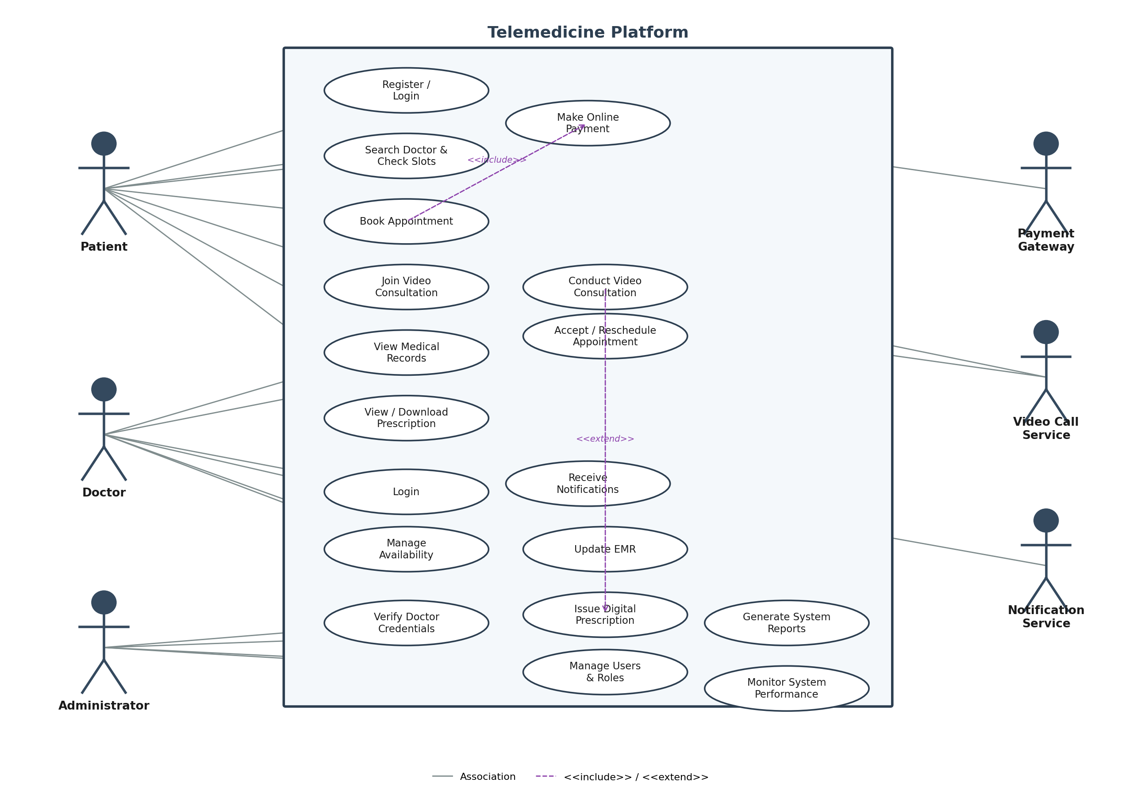
Figure 1: Use Case Diagram — Telemedicine Platform

6.4 Detailed Use Case Descriptions
Three representative use cases are elaborated below to illustrate the primary interaction flows.
Use Case: Book Appointment
Use Case ID | UC-03
Use Case Name | Book Appointment
Primary Actor | Patient
Precondition | Patient is registered and logged in; desired doctor's availability is visible.
Main Flow | 1. Patient searches for a doctor by specialization/availability.  2. System displays a list of matching doctors with available time slots.  3. Patient selects a doctor and an available time slot.  4. System temporarily reserves the slot and prompts for payment (include: Make Online Payment).  5. Patient completes payment via the integrated payment gateway.  6. System confirms the appointment and sends a confirmation notification to the patient and doctor.
Alternate Flow | If payment fails, the reserved slot is released after a timeout and the patient is prompted to retry. If the selected slot is taken by another patient before payment completes, the system prompts the patient to choose an alternate slot.
Postcondition | Appointment is created with status 'Booked'; slot is removed from doctor's availability; confirmation notifications are sent.

Use Case: Conduct Video Consultation
Use Case ID | UC-05
Use Case Name | Conduct Video Consultation
Primary Actor | Doctor
Precondition | Appointment status is 'Booked' and the scheduled time has arrived; both patient and doctor have working internet connectivity.
Main Flow | 1. Doctor and patient join the consultation room from their respective dashboards at the scheduled time.  2. System authenticates both parties and establishes a secure video session via the Video Call Service.  3. Doctor reviews the patient's EMR and consultation history during the call.  4. Doctor conducts the consultation and records diagnosis/notes in the EMR.  5. Doctor optionally issues a digital prescription (extend: Issue Digital Prescription).  6. System marks the appointment status as 'Completed' and stores the consultation summary.
Alternate Flow | If video connection fails, the system offers an audio-only fallback. If the doctor does not join within a grace period, the system notifies the patient and offers rescheduling.
Postcondition | Consultation is recorded as completed; EMR is updated; prescription (if issued) is linked to the appointment and made available to the patient.

Use Case: Verify Doctor Credentials
Use Case ID | UC-10
Use Case Name | Verify Doctor Credentials
Primary Actor | Administrator
Precondition | A doctor has submitted a registration request with license and qualification documents.
Main Flow | 1. Administrator opens the pending doctor-verification queue.  2. Administrator reviews submitted license number, qualification certificates, and identity documents.  3. Administrator cross-checks credentials against records or a regulatory registry (manual or API-based).  4. Administrator approves or rejects the registration, optionally requesting additional documents.  5. System updates the doctor's account status and notifies the doctor of the outcome.
Alternate Flow | If documents are insufficient, the administrator marks the request 'Pending Documents' and the doctor is notified to resubmit.
Postcondition | Doctor's account is marked 'Verified' (enabling patient bookings) or 'Rejected/Pending Documents'.

7. Data Requirements
The system shall persist and manage the following key data entities:
Entity | Key Attributes
Patient Profile | PatientID, Name, DOB, Gender, Contact No., Email, Address, Emergency Contact, Insurance Info
Doctor Profile | DoctorID, Name, Specialization, Qualification, License No., Experience, Consultation Fee, Availability
Appointment | AppointmentID, PatientID, DoctorID, Date, Time Slot, Status (Booked/Completed/Cancelled), Mode
Electronic Medical Record (EMR) | RecordID, PatientID, Diagnosis, Symptoms, Consultation Notes, Attached Reports, Timestamp
Prescription | PrescriptionID, AppointmentID, DoctorID, Medicines (name, dosage, duration), Instructions, Digital Signature
Payment Transaction | TransactionID, PatientID, AppointmentID, Amount, Payment Mode, Status, Timestamp, Invoice No.
Notification Log | NotificationID, RecipientID, Type (SMS/Email/Push), Content, Status, Timestamp

8. External Interface Requirements

8.1 User Interfaces
- Responsive web application accessible via desktop and mobile browsers, with role-specific dashboards for Patients, Doctors, and Administrators.
- Consultation room interface with video/audio controls, chat, and access to patient EMR (doctor view) during the call.

8.2 Hardware Interfaces
- Client devices (desktop/laptop/smartphone) with a camera, microphone, and internet connectivity for video consultations.

8.3 Software Interfaces
- Payment Gateway API (e.g., card/UPI/net-banking processor) for transaction processing.
- Video Conferencing/WebRTC Service API for real-time audio-video communication.
- SMS/Email/Push Notification Gateway API for automated alerts and reminders.
- Optional integration with hospital EMR systems via HL7/FHIR standards.

8.4 Communication Interfaces
- All client-server communication shall occur over HTTPS/TLS; video sessions shall use encrypted WebRTC/SRTP channels.

9. System Features
- Patient & Doctor Onboarding — self-service registration with document upload and admin-verified doctor onboarding.
- Appointment Scheduling — real-time slot availability, booking, rescheduling, and cancellation.
- Secure Video Consultation — encrypted, low-latency audio-video sessions with fallback to audio-only.
- Electronic Medical Records (EMR) — structured storage of diagnosis, notes, and consultation history accessible to authorized doctors and the owning patient.
- Digital Prescription Management — creation, digital signing, and patient-side download of prescriptions.
- Integrated Payments — secure checkout, invoicing, and transaction history.
- Automated Notifications — booking confirmations, reminders, and status alerts via SMS/email/push.
- Administration & Reporting — user management, doctor verification, and operational dashboards/reports.

10. Assumptions and Constraints

10.1 Assumptions
- Patients and doctors have access to a stable internet connection and a camera/microphone-enabled device.
- Doctors onboarding onto the platform hold valid, verifiable medical licenses.
- A third-party payment gateway and video-conferencing/WebRTC provider will be available for integration.
- Patients provide accurate personal and medical information during registration.
- The initial deployment targets a single country/region, simplifying regulatory and payment-currency handling.

10.2 Constraints
Type | Constraint
Technical | The system must integrate with third-party video conferencing and payment APIs, whose rate limits and downtime are outside the platform's control.
Operational | Doctor availability and consultation quality depend on doctors' adherence to schedules and stable network conditions on both ends.
Economic | The project must operate within a limited development and infrastructure budget, favoring cloud-managed and open-source components where feasible.
Legal/Regulatory | The system must comply with healthcare data protection regulations (e.g., HIPAA or regional equivalents) governing storage, access, and retention of patient health data.
Time-Related | The system must be delivered within the academic/project timeline, constraining the scope of the initial release to core modules (registration, scheduling, consultation, records, payments).

11. Validation of Requirement Completeness and Consistency

11.1 Stakeholder Coverage Check
Each identified stakeholder — Patient, Doctor, and Administrator — has at least one functional requirement and use case addressing their core need: patients can discover, book, pay for, and attend consultations and retrieve records; doctors can manage schedules, consult, and prescribe; administrators can verify, manage, and monitor. This confirms all primary stakeholder needs identified in Section 1.3 are addressed within Sections 4 and 6.

11.2 Ambiguity, Redundancy, and Consistency Review
- Ambiguity: Requirement wording avoids vague terms (e.g., "fast", "secure enough") by attaching measurable criteria in the NFR table (e.g., latency ≤ 2 seconds, uptime ≥ 99.5%, AES-256 encryption).
- Redundancy: Overlapping concerns (e.g., notifications) are consolidated into a single Notification Service interface rather than duplicated per module.
- Consistency: Terminology (e.g., "EMR", "Appointment", "Prescription") is used uniformly across the FR, NFR, use case, and data requirement sections to avoid conflicting definitions.
- Traceability: Every use case in Section 6 maps back to one or more functional requirements in Section 4 (e.g., UC-03 Book Appointment ↔ FR-03, FR-10; UC-05 Conduct Video Consultation ↔ FR-05, FR-06, FR-07).

11.3 Missing Requirement Check
Cross-checking objectives (Section 1.4) against requirements confirms coverage for security/privacy (FR-12, NFR-Security, NFR-Compliance), scalability (NFR-Scalability), and usability (NFR-Usability). No stated objective is left without a corresponding requirement.

11.4 Suggested Improvements
- Introduce a formal requirements traceability matrix (RTM) linking objectives → FRs → use cases → test cases for larger-scale development.
- Add explicit requirements for offline/low-bandwidth degraded modes, given the target rural/underserved user base.
- Define precise SLAs with third-party payment and video providers to firm up currently qualitative constraints.
- Conduct a formal stakeholder review/walkthrough session to validate this SRS before moving to design.

— End of Document —

